# Virtual Assistant Evaluation Toolkit

## Prerequisites

### Software

[Python](https://www.python.org/downloads/) - A general purpose programming language well suited to data science

[Anaconda](https://www.anaconda.com/products/individual) - A data science platform that comes pre-packaged with Jupyter notebooks

[Visual Studio Code](https://code.visualstudio.com/) (optional) - A popular development environment that makes it easy to edit code

### Code

You require the toolset codebase. It is available from:

* [Github](https://github.com/chungleu/IntentTraining) (invitation required)
* As a zip file. Available from Paysafe colleagues

### Example Datasets

You can use real data from the training sets and production of your virtual assistant. Alternatively, this file will come attached with dummy data about puppies:

* Puppy_Training_data.csv
* Puppy_Blindset.csv
* Skill-Puppy.json  
  If using this dummy set, we will need to create a new skill by importing this .json file

## Setup

### Installation

1. In your command prompt (Anaconda prompt or regular if you have python separately installed), navigate to the root of the **intent_training_tools** codebase.  
   The command for this will be:

*cd <the file path to your codebase>*

e.g. *cd /Users/chungleu@uk.ibm.com/Documents/Projects/intent_training_tools*

1. Run the command to install all the project dependencies

*pip install -r requirements.txt*

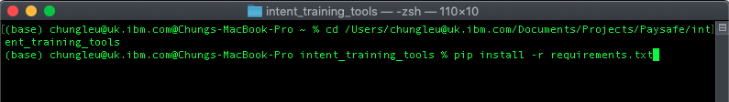

### Config

1. Navigate to the root of the **intent_training_tools** codebase (either in file explorer or Visual Studio Code)
2. Create **config.py** and **Credentials.py** files. You can use the sample files by just amending the names
   1. **config.py** contains editable configurations for testing and text processing.  
      (optional) edit this file if you want to tweak the default configurations.
   2. **Credentials.py** contains the credentials that we’ll be using to connect to our Watson Assistant service

[File explorer view of the config and credentials files that need to be changed]

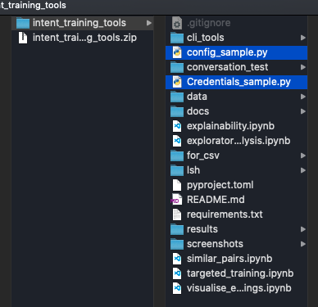

1. Update your **Credentials.py** file with your Watson credentials
   1. Navigate to your Watson Assistant skill to find the API details  
      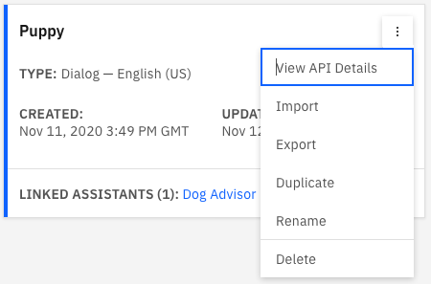  
        
      Graphical user interface, application, Teams

      Description automatically generated
   2. Update the Adoptions names with the skill names you want to test

[Jupyter notebook view of the **Credentials.py** file with changes]  
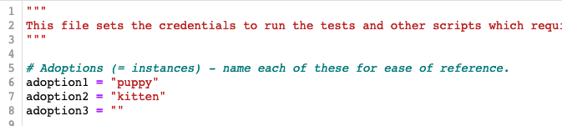

* 1. Update the Service Credentials with your **url**, **apikey**, and **skill name**

Your **url** is the first section of the long URL in your skill’s API details, probably:   
<https://api.eu-gb.assistant.watson.cloud.ibm.com>

At the time of writing, the Paysafe Watson Assistant is hosted in the UK so the URL endpoint above is correct. If it ever moves, the API details will show the updated URL. You can also check the regionally appropriate URLs in the [IBM Watson documentation](https://cloud.ibm.com/apidocs/assistant/assistant-v1#service-endpoint).

Your credentials should then look something like this:

[Jupyter notebook view of the **Credentials.py** file with **API key** and **Skill ID**]

* 1. Final credentials update. Update your workspace IDs at the bottom:

[Jupyter notebook view of the **Credentials.py** file with **Skill ID** in workspace IDs]

* 1. All set!

## Load Local Data

1. Navigate to your **data** subfolder within your **intent_training_tools** using your file explorer or Visual Studio Code.  
   It should currently be empty except for a **.gitignore** file.

[File explorer view of the **data** subfolder - before copying across the training data]  
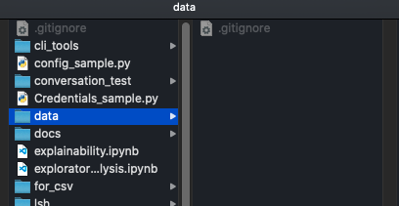

1. Add your blindset data into the **data** folder
2. Create a subfolder called **workspace_training** and put your K-Fold training data in there.
3. Using our sample data, the folder structure now looks like the below. You can (optionally) add multiple data files for each.

[File explorer view of the **data** subfolder - after copying across the training data]

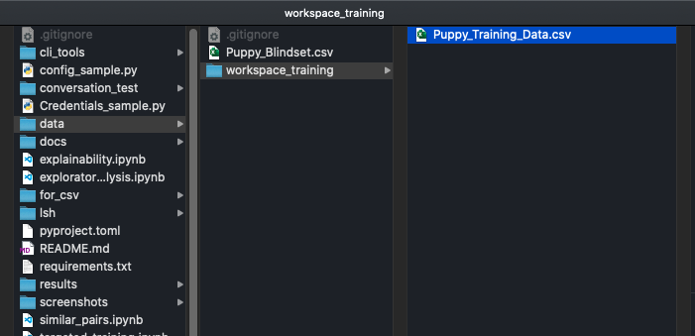

## Running the Toolset

You should now be ready to run the tools.

### Exploratory Analysis

This notebook contains a set of tools to analyse the intents within your Watson Assistant skill for common issues that can lead to confusion and lower confidence.

1. In Jupyter Notebook, navigate to your codebase and open **exploratory_analysis.ipynb**
2. Ignore the pip install commands at the top. You have already installed these packages.

[No need to re-install!]  
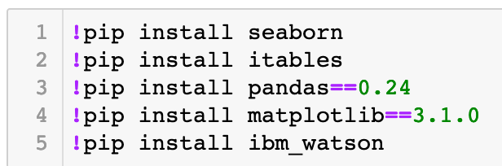

1. Run the cell to import the packages, internal dependencies, and configuration.

[Jupyter notebook cell to run]  
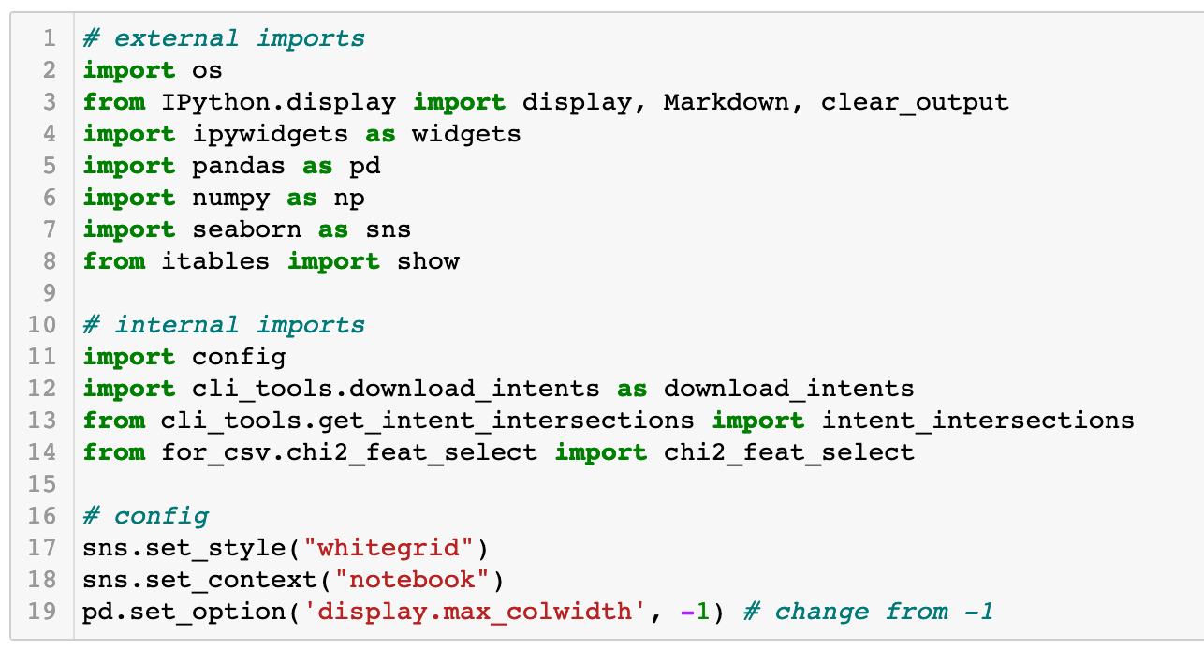

1. Now we will get the data we want to analyse. Running the cell below will return a list of all the training data that exists in your **data/workspace_training** subfolder. This is the data available to be analysed  
     
   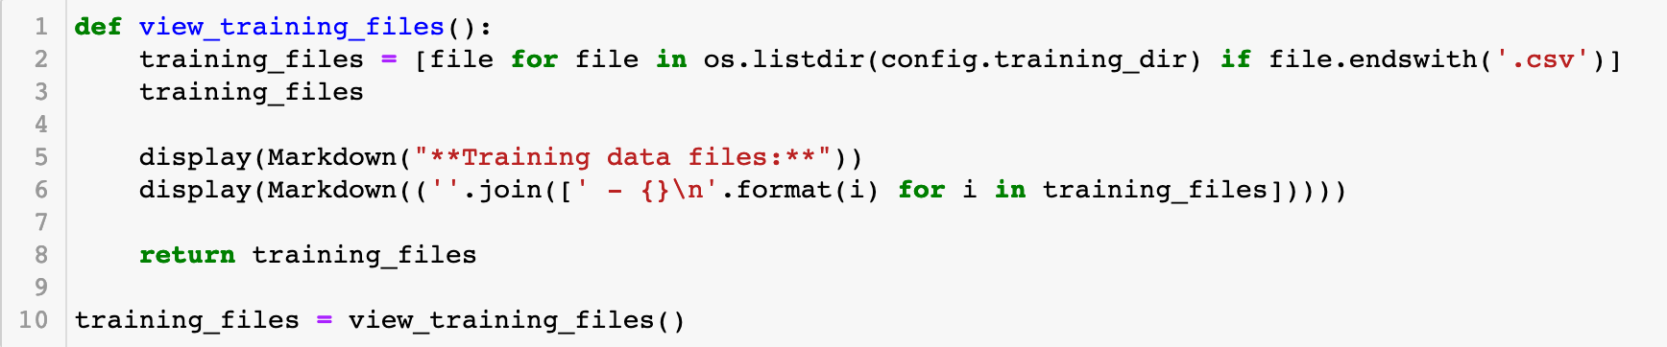
2. Run this cell to generate a button that you can click to (optionally) update your list of training files to evaluate  
   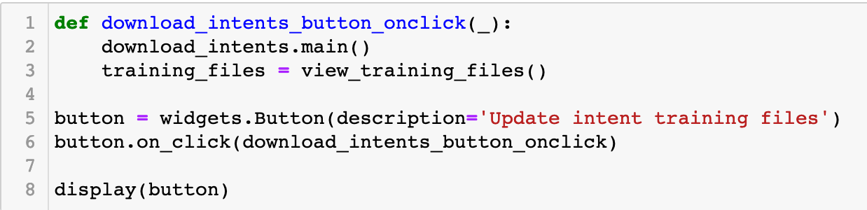
3. Clicking the **Update Intent Training Files** button will download all the training data available using your credentials.  
   The data will be saved to your local **data/workspace_training** subfolder.

Be aware that Watson Assistant has limits on how many datasets can be downloaded in a short period of time. If too many people are trying to update their datasets at the same time, you will be rate limited.  
  
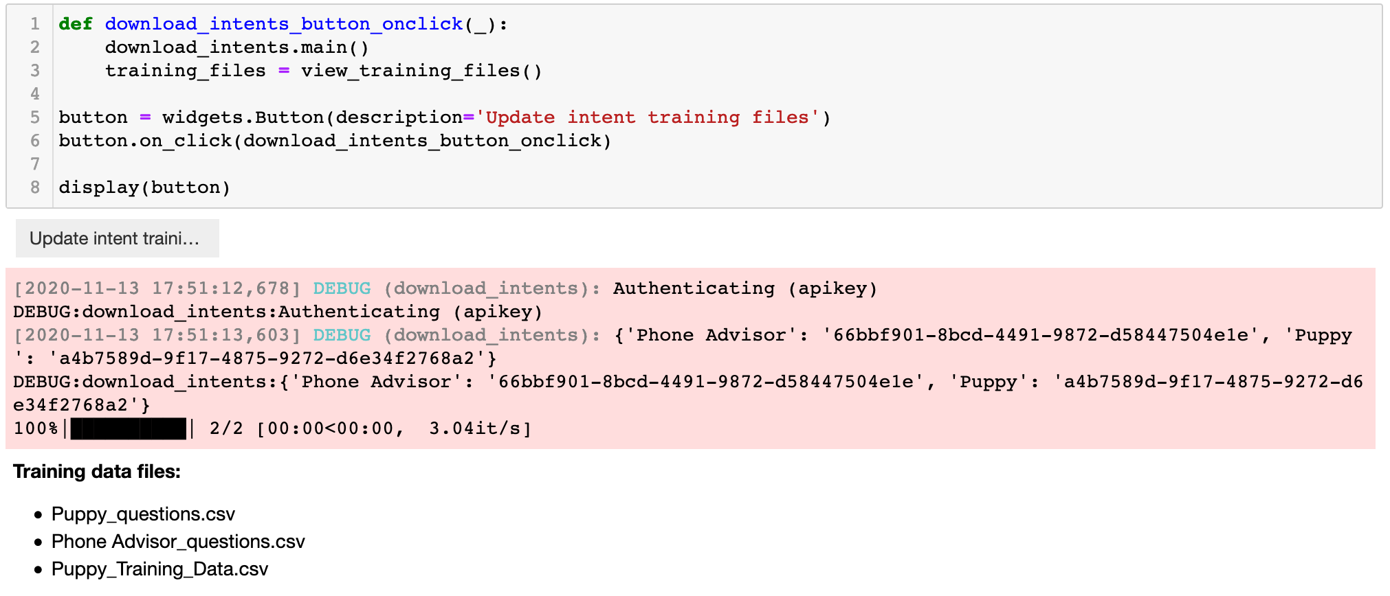

1. Running the next cell will give a dropdown menu of skills  
     
   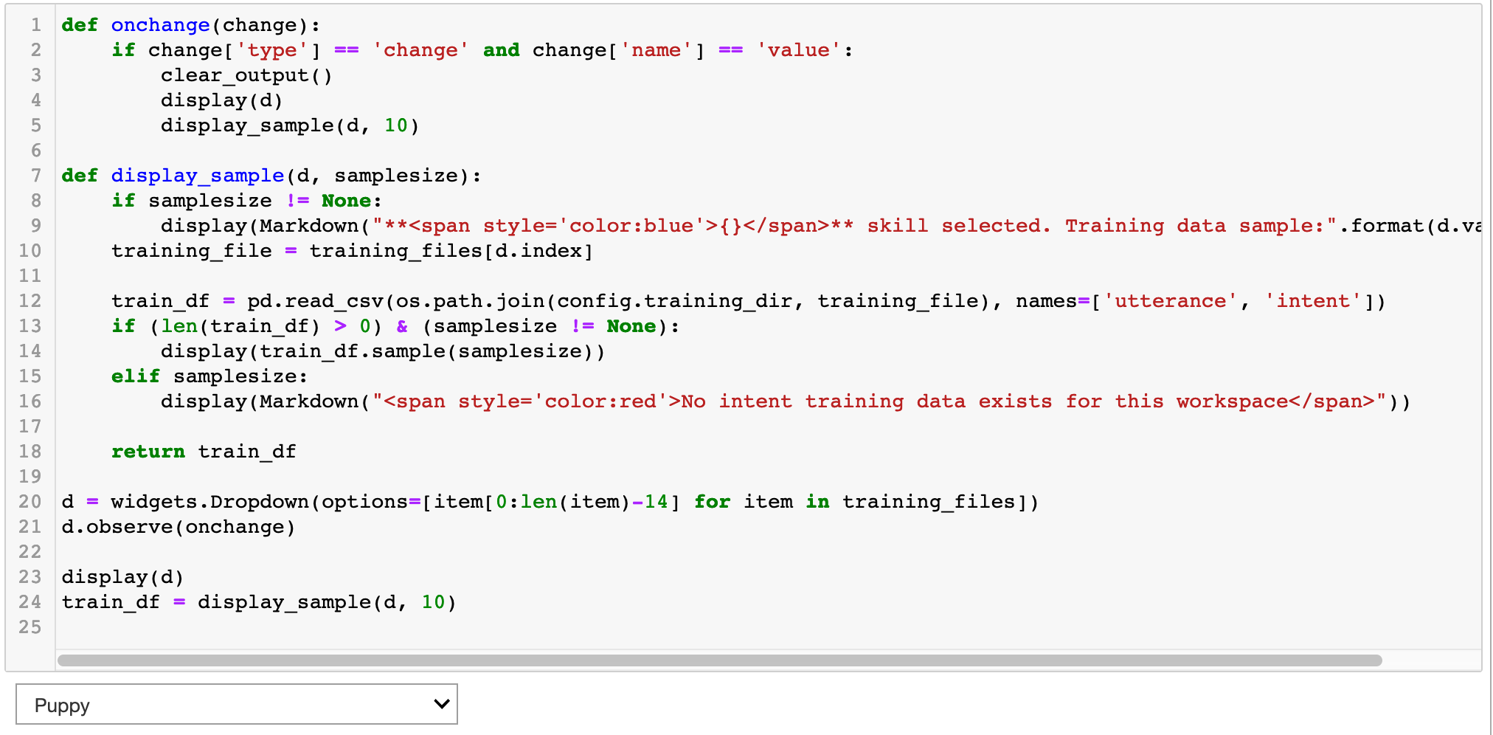
2. Selecting one of the skills from the dropdown menu will provide a random sample of utterances and the intents they’re trained to match  
     
   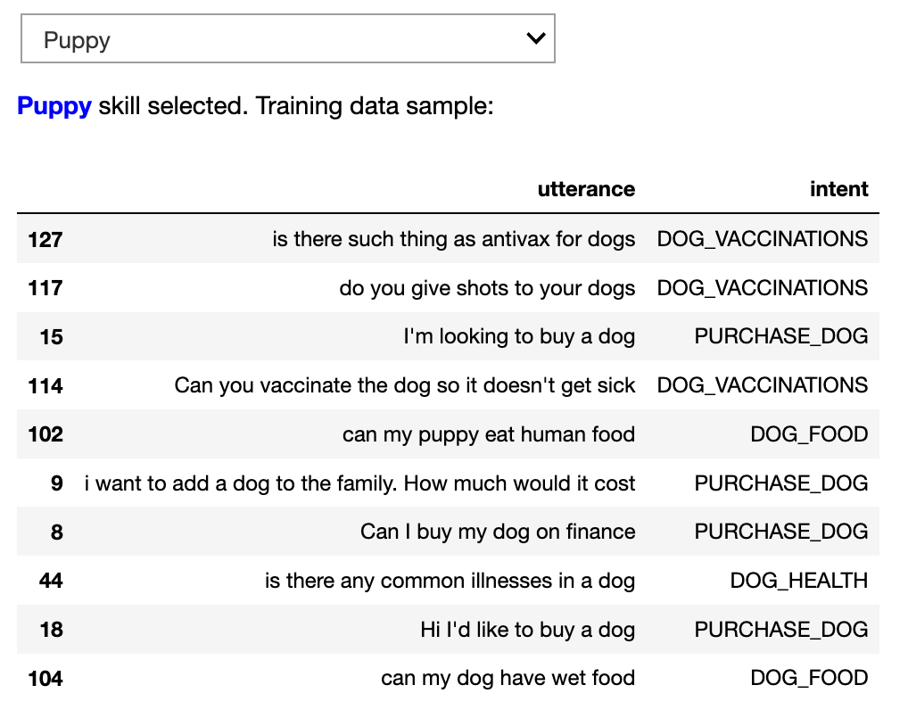

#### Analysis

1. **Intent Sizes**  
   Running the next cell will show you the number of utterances that have been used in the training for each intent.  
   The number of utterances should be proportional to the amount of scope they cover. This does *not* necessarily mean the numbers in each should be the same.   
     
   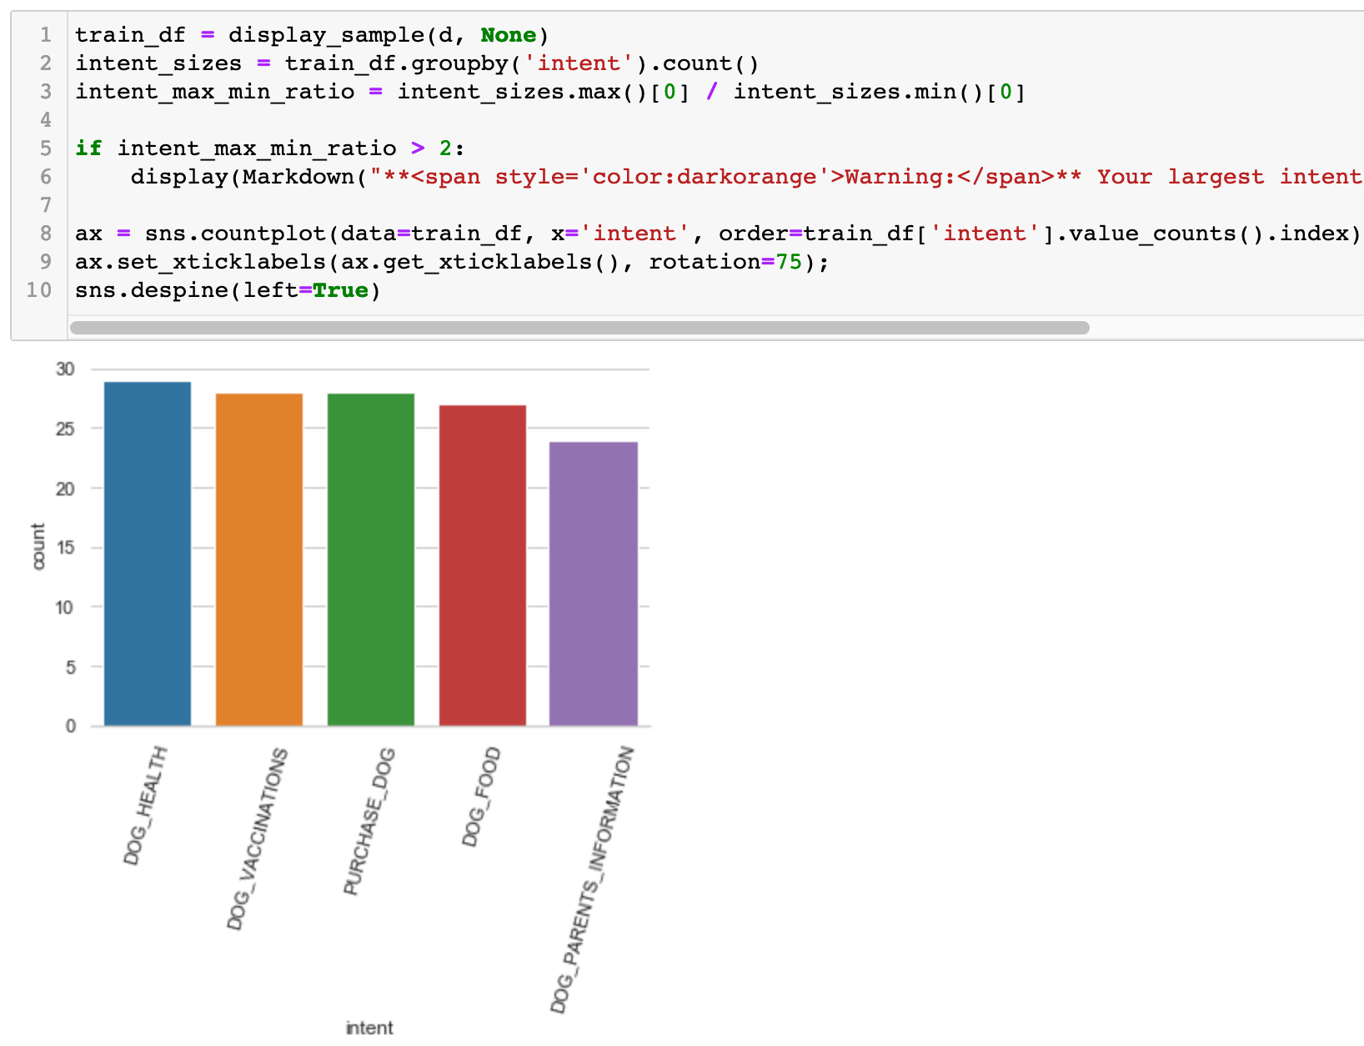

1. **Representative N-Grams**This next cell uses chi-squared feature selections to understand the n-grams (combinations of n-number of words) that are important in each intent.  
   You should be checking whether:
   1. These terms are what you’d expect for each intent
   2. Any of these terms would be good candidates for resting entities

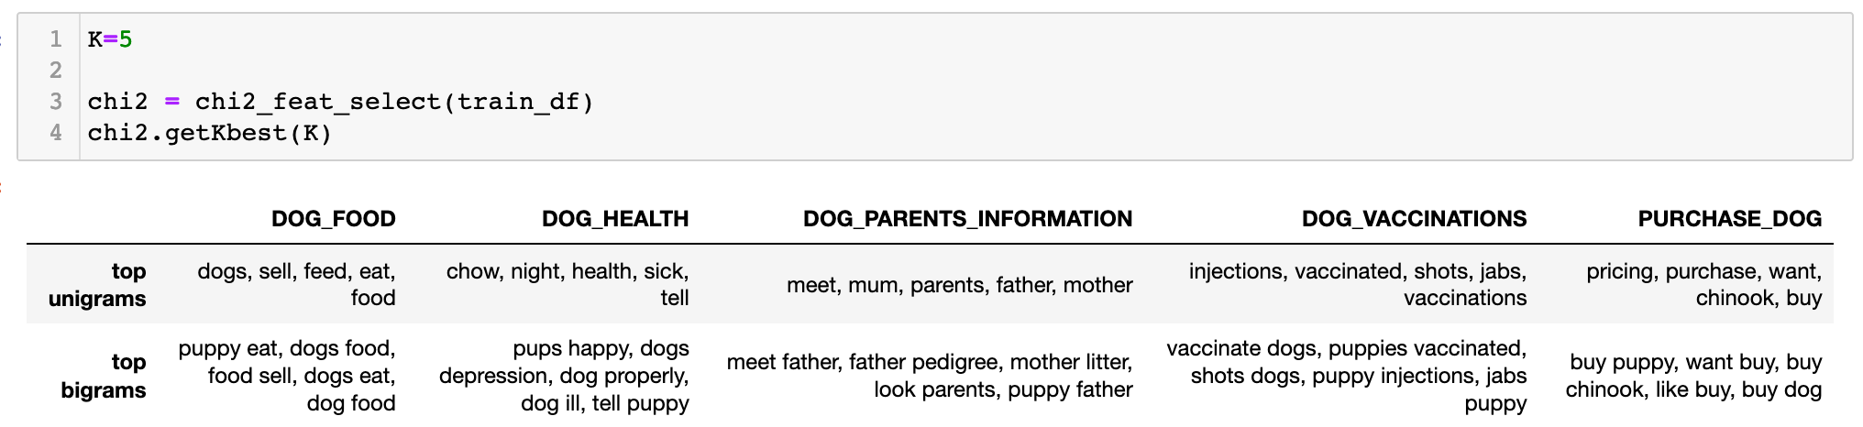

1. **Intent Overlap**

Running all the cells in the next section shows the number of phrases that overlap in different intents. If there are lots of overlapping n-grams, it is worth investigating why this is the case as it can lead to model confusion.

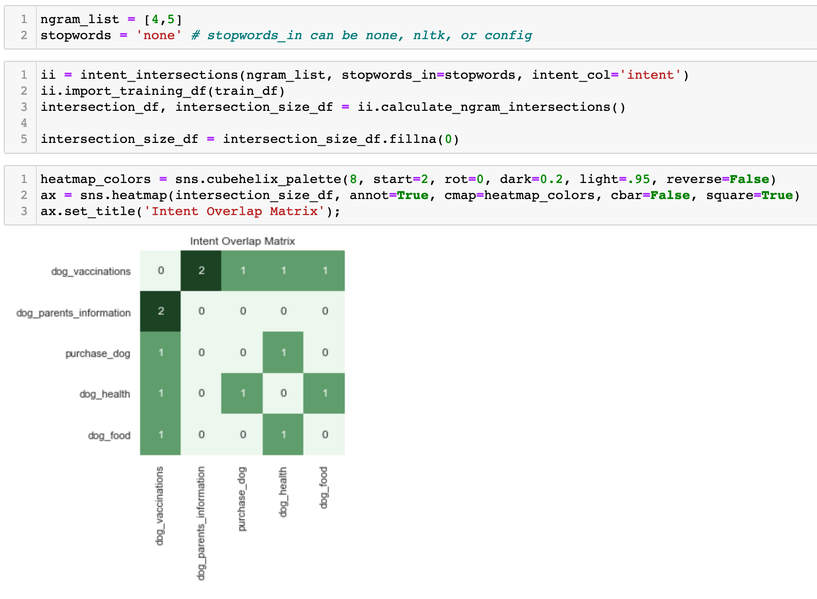

1. Running the next cell shows you the phrases that overlap for each combination of skills  
   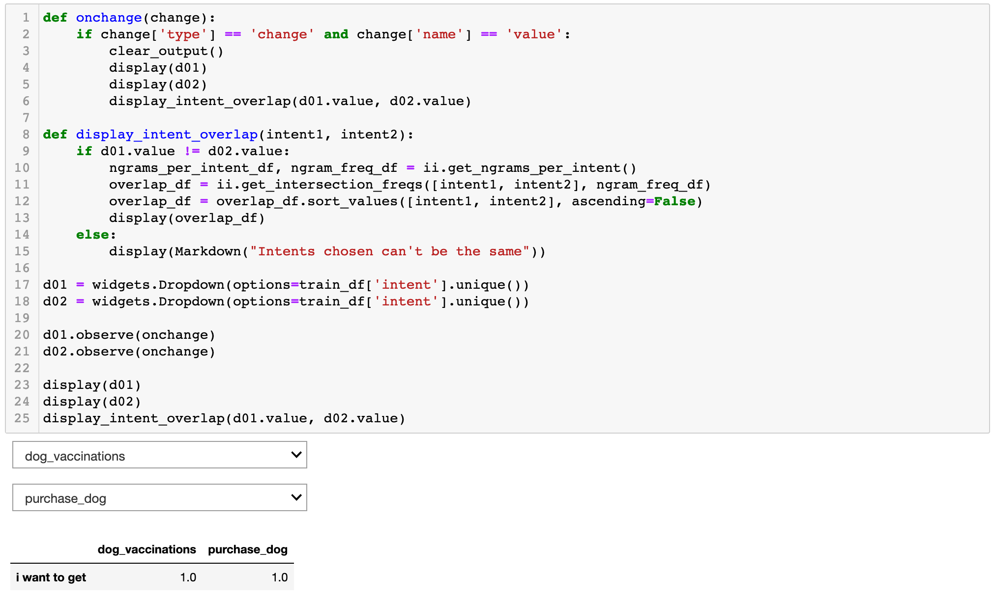
2. Running the final cell will show a table to search through training utterances  
   

### Targeted Training

This notebook contains tools to run K-Fold tests and investigate the data that it returns

1. In Jupyter Notebook, navigate to your codebase and open **targeted_training.ipynb**
2. Ignore the first cell. We’ve already installed all our dependencies  
   Text

   Description automatically generated
3. Run the next cell to import all our external and internal packages  
   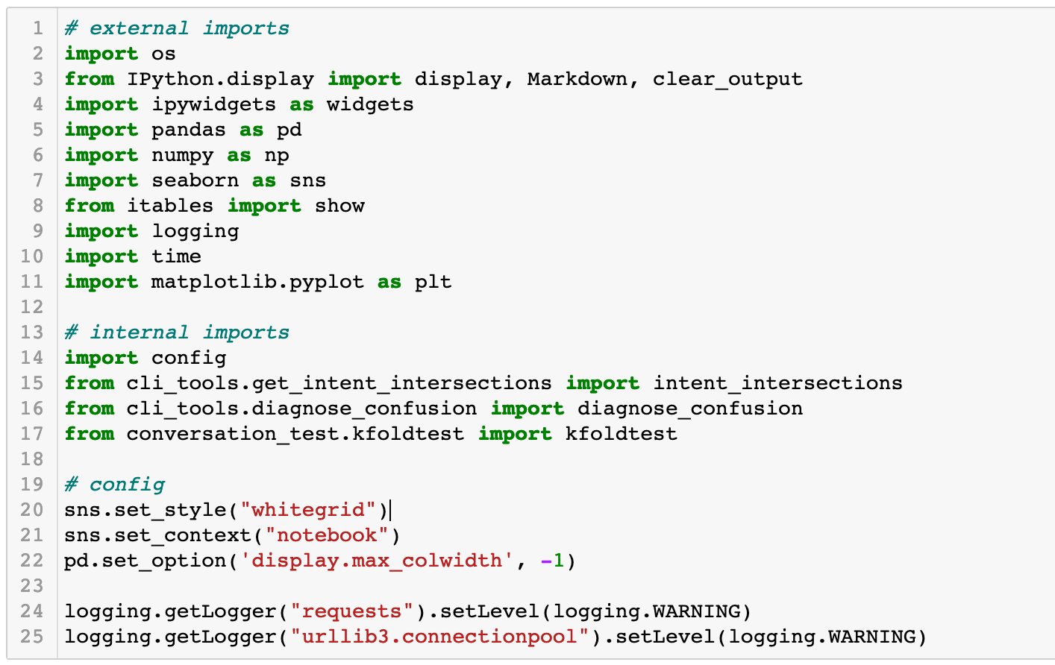
4. Create 2 new cells below the import cell.  
   In the first one, write:

*import nltk  
nltk.download(‘stopwords’)*

In the second one, write:  
*%matplotlib inline*  
  
Run both cells. These will ensure that the nltk stopwords are downloaded, and that the charts are displayed within the notebook.  
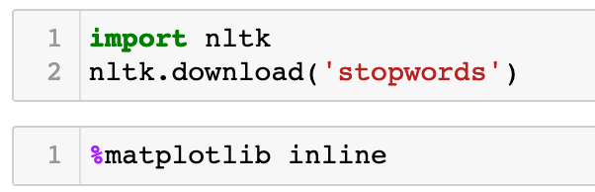

1. Run the next cell to generate a dropdown list of available skills.  
   Use the dropdown list to select the skill for which you want to run the K-Fold test  
   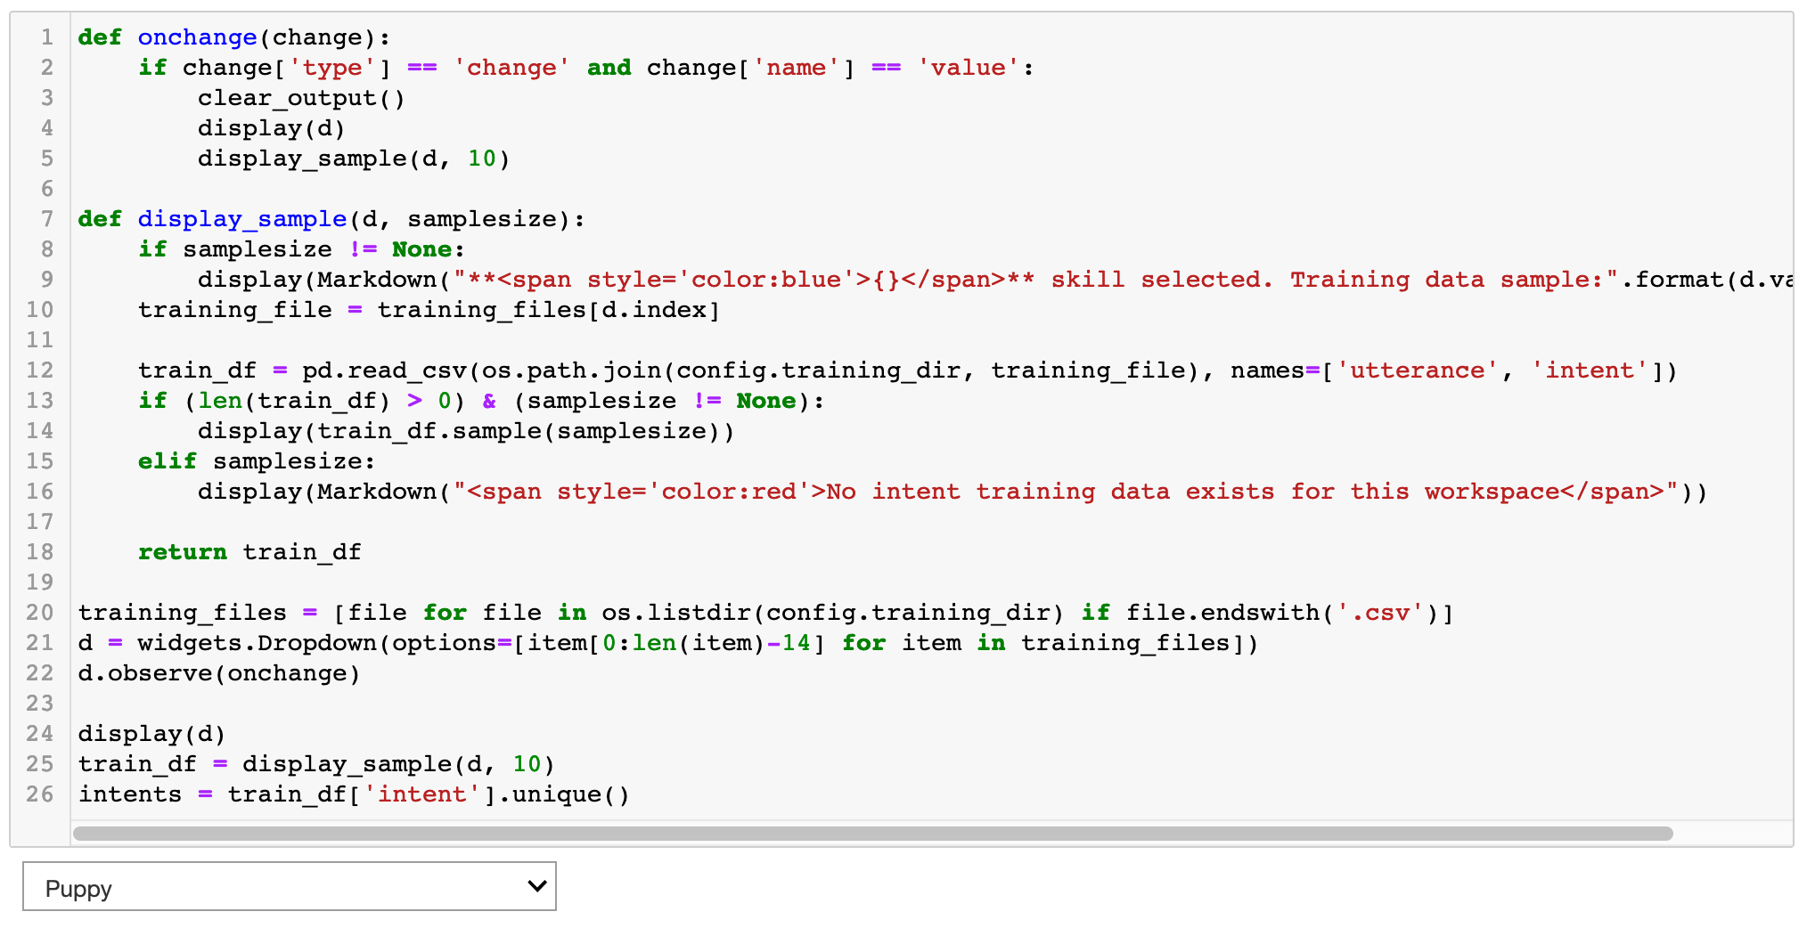
2. In the next cell, we need to set the configuration for our K-Fold test. You should ensure that the following are especially set correctly:  
   - apikey  
   - url  
   - workspace_id  
   - nfolds The number of folds that you want to use in the test. This is typically between 5-10

Run the cell once updated

#### Running the K-Fold Test

1. Run the next cell. This will initiate the K-Fold test.

Be aware that the K-Fold test creates K-number of workspaces to test your testing folds. As standard, the Watson Assistant service allows for 50 workspaces at the same time. If you do not have space, you may need to choose a lower k-number for your test, or reconsider your workspace architecture e.g. having workspaces in different Watson Assistant services

The new workspaces will be deleted after testing is complete, but the Watson Assistant UI will still look cluttered until it is complete. It is recommended that you do not have too many people running K-fold tests at the same time because it will look messy and you may collectively exceed the limit of 50 workspaces.

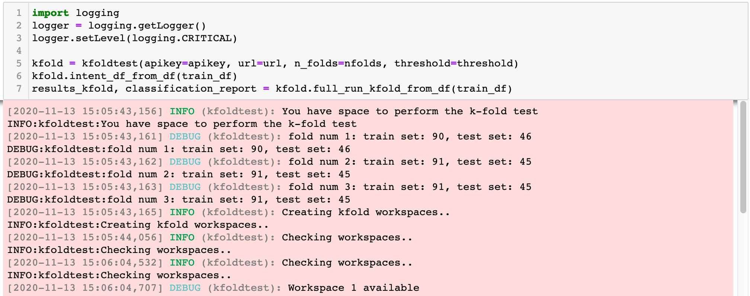

1. Running the next cell lets you select the metric you are most concerned about:
   * Precision
   * Recall
   * Accuracy
   * F1 Score

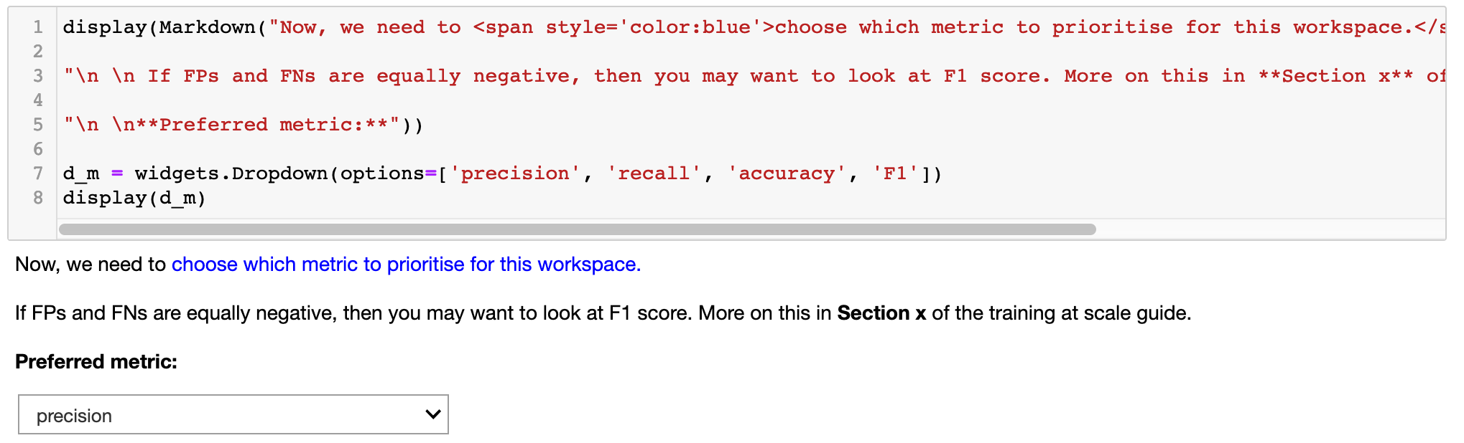

1. Running the next cell generates a table listing the performance metrics for each of the intents in your selected skill. The intents will be ordered by your preferred metric, set in the step above

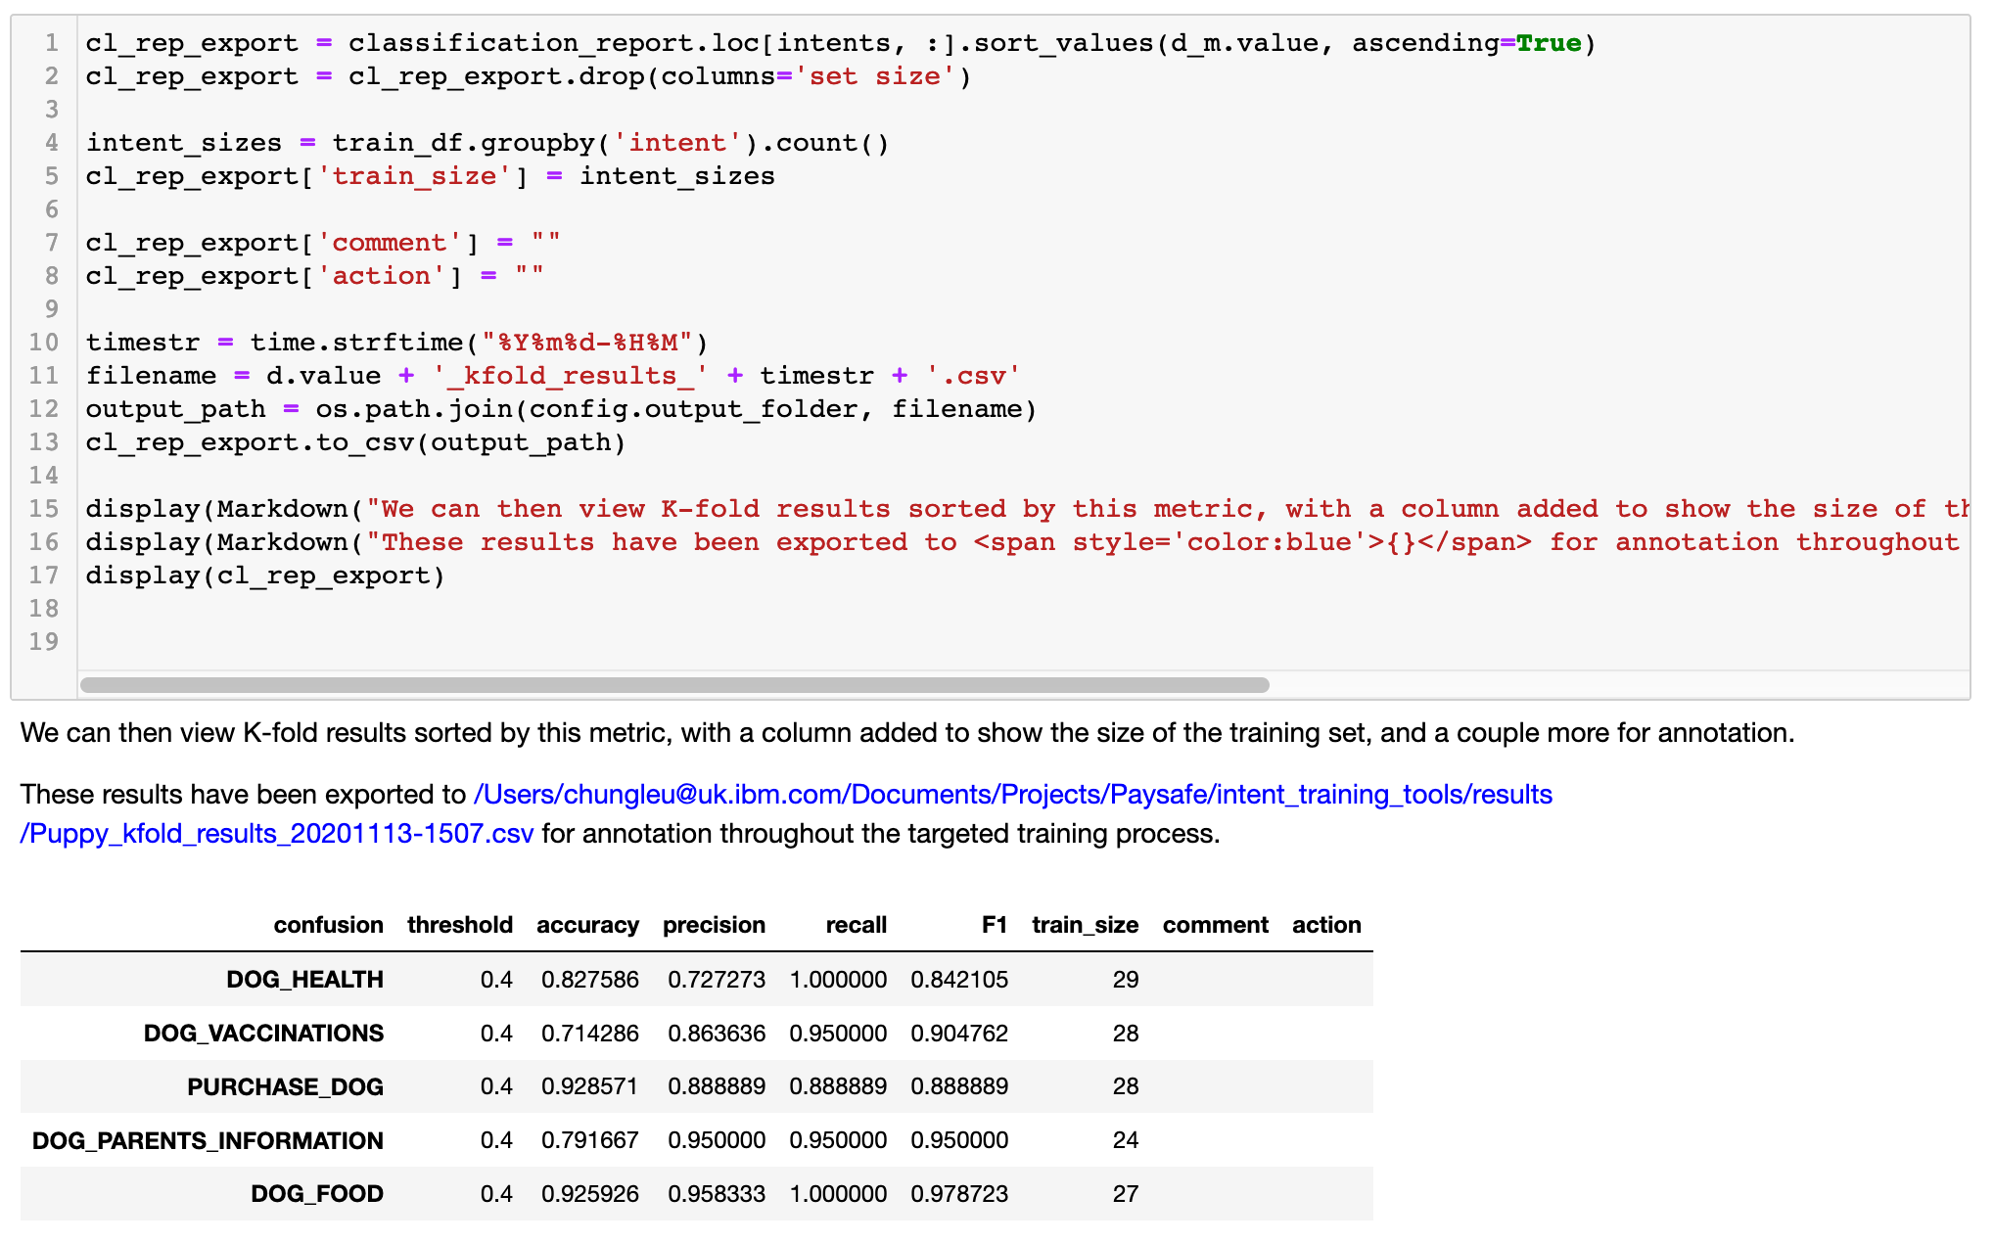

1. Running the next cell shows the same table in a graphical format  
   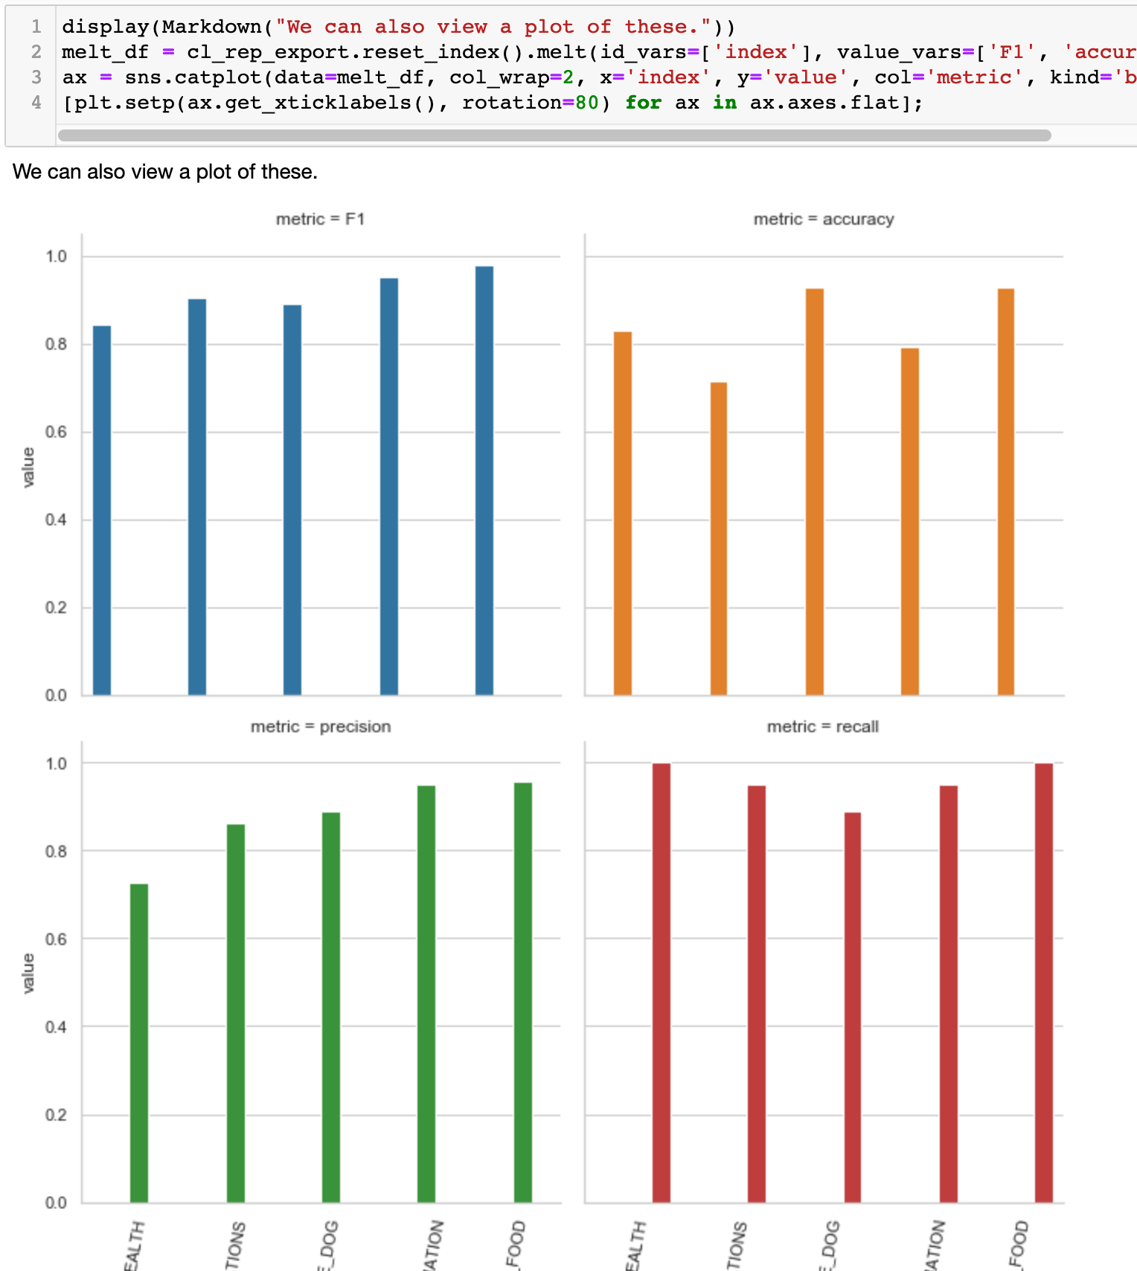

#### Root Cause Analysis

1. Running the next cell shows a chart comparing **training size vs Recall** for each intent.  
   If an intent is showing in the bottom left corner of the chart, it suggests that it has **low recall** (the intent is not being matched very often) because the training set size may too small for it to match with enough confidence.  
     
   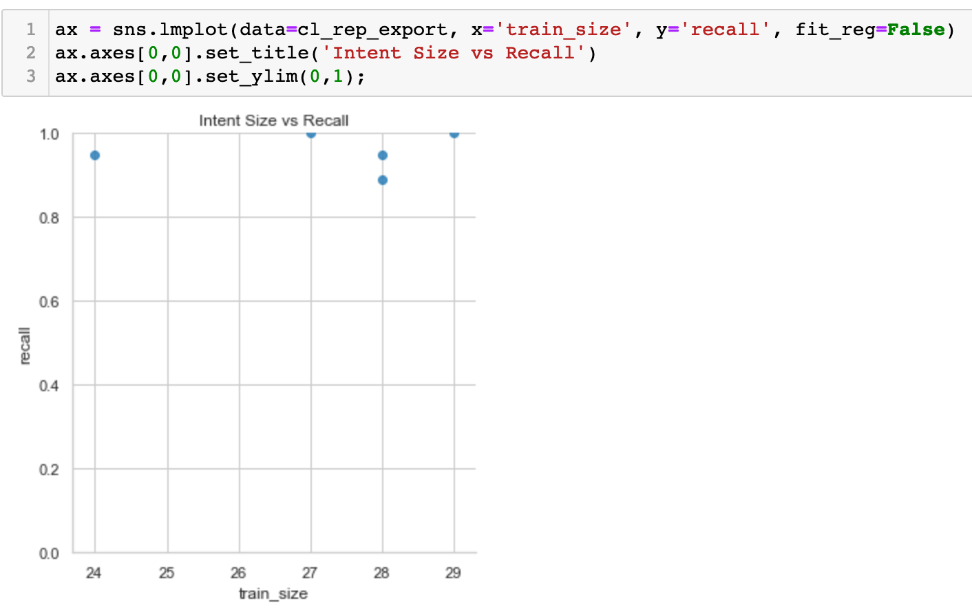
2. Running the next 2 cells shows the amount of **Intent Overlap**  
   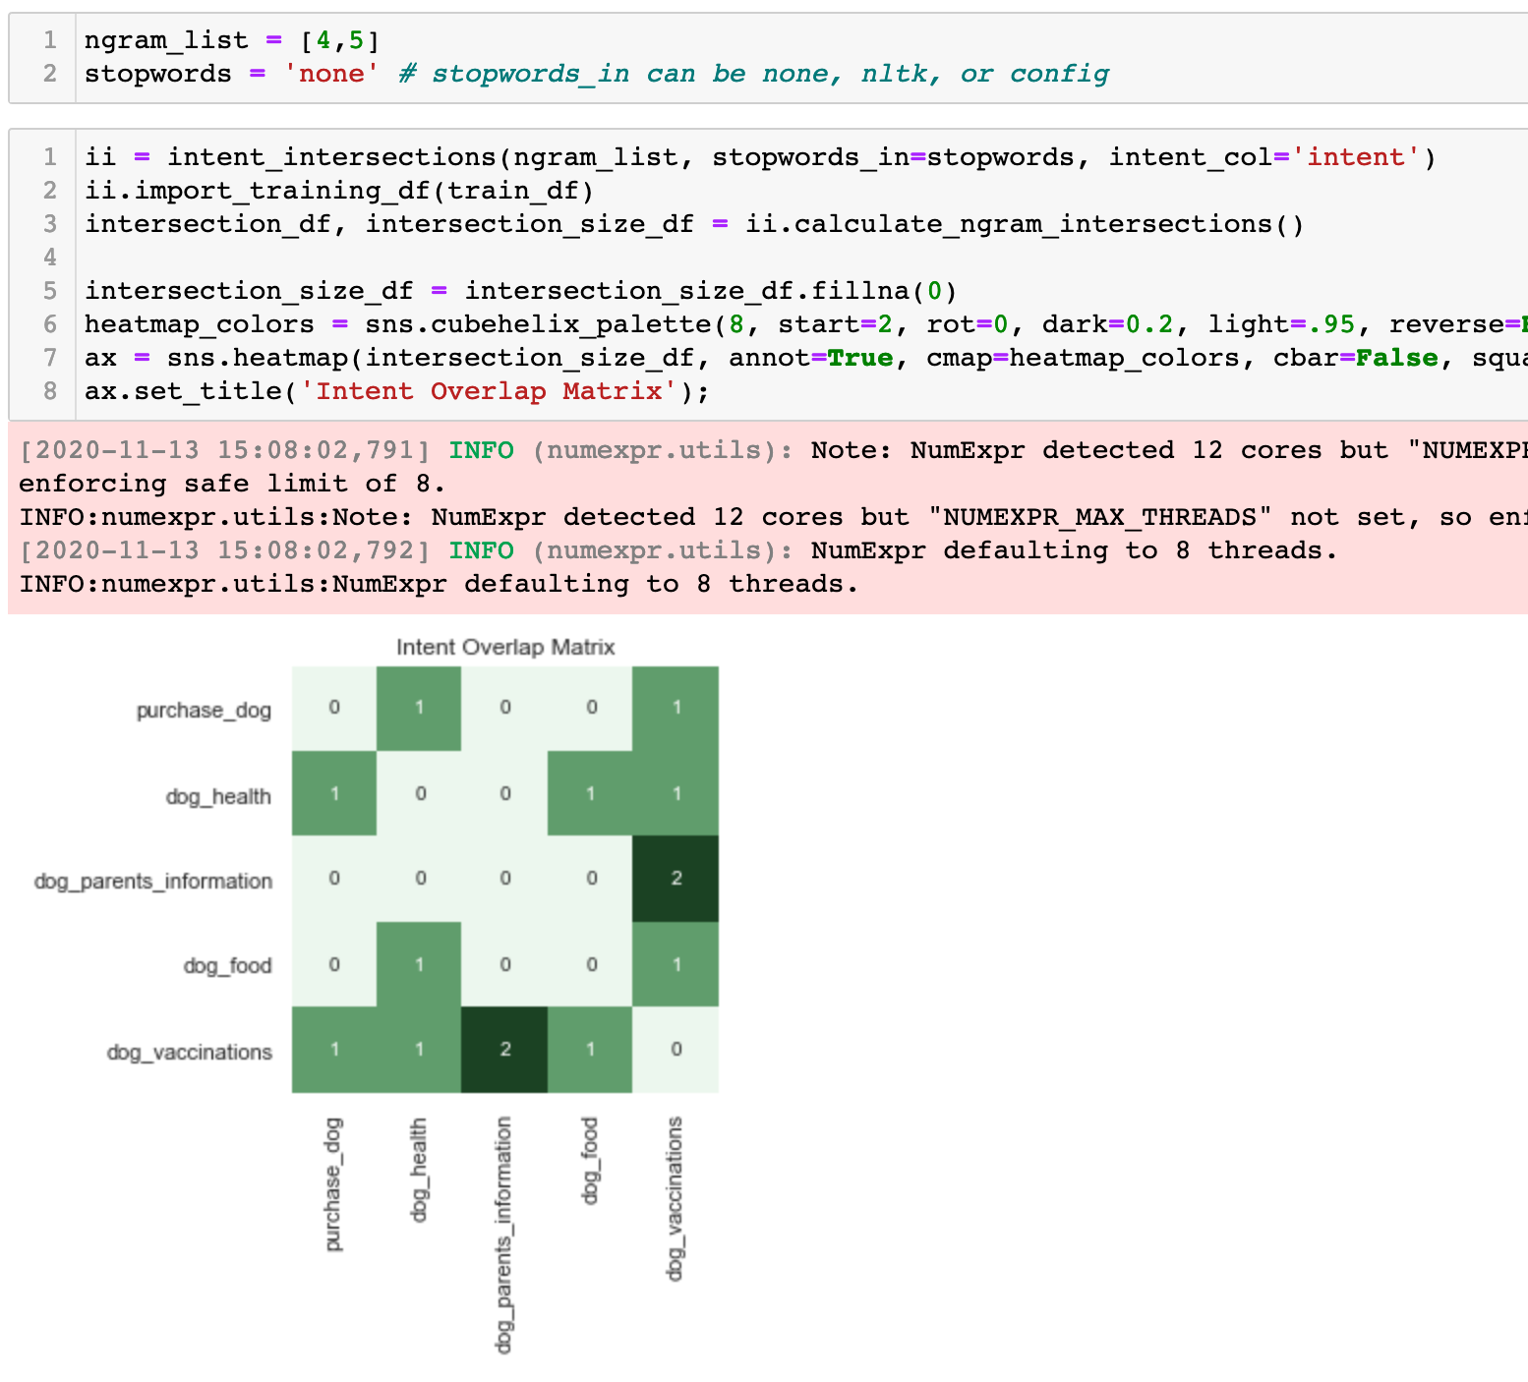
3. In similar fashion to the **exploratory_analysis.ipynb** notebook, you can inspect pairs of intents to see the phrases that overlap in each.

Some overlap is to be expected, but a large number of overlapping phrases requires greater investigation.  
  
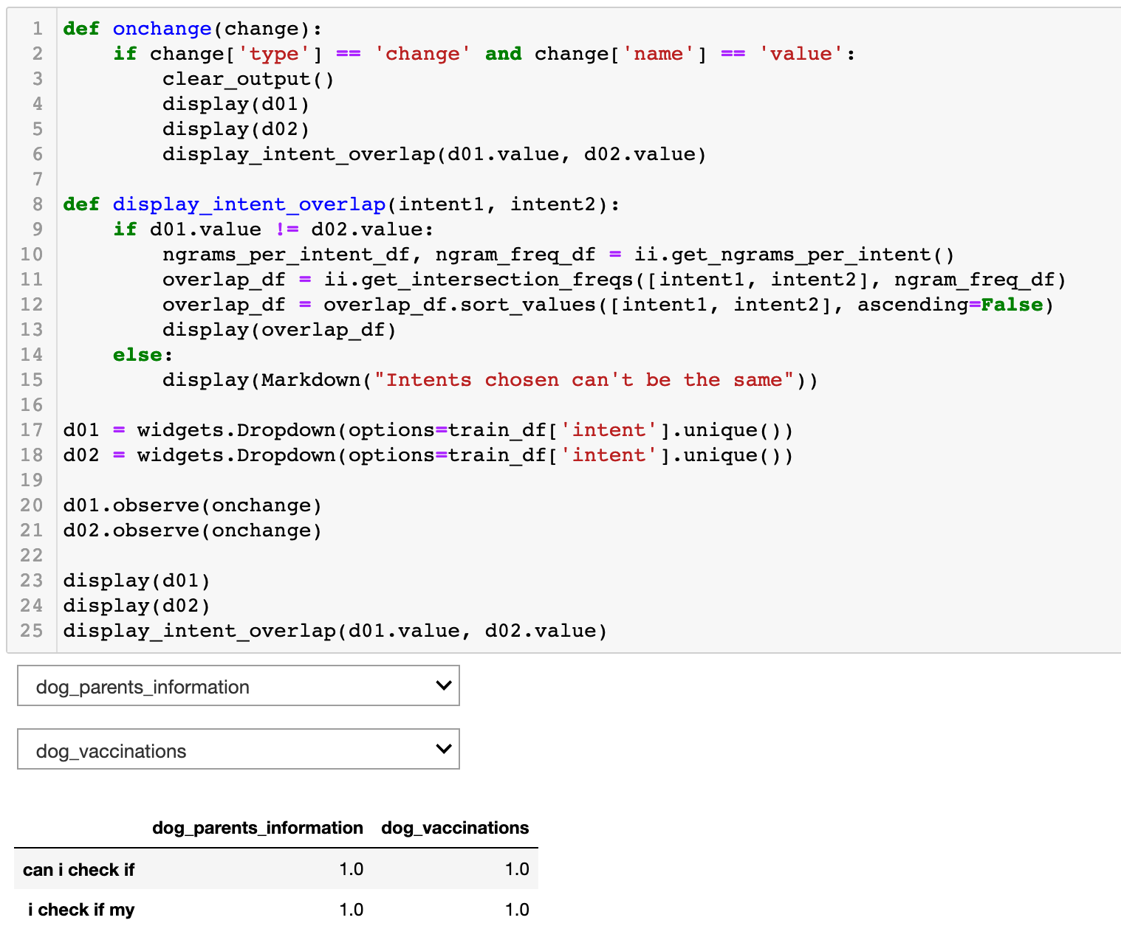

1. The final tool to inspect common errors is the **utterance-confusion** tool.

Running this cell allows you to type a phrase into the entry box and see a list of training utterances and their assigned intents that contain similar n-grams as your phrase.  
This helps you identify the phrases and n-grams that have shared components in different intents.

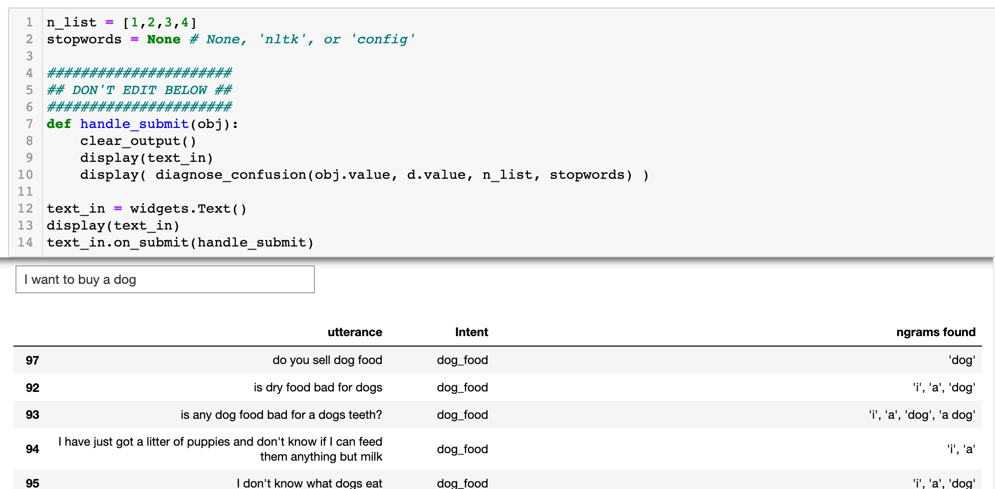

### Command Line Tools - Blindset Testing

The toolkit supports the application of other tests via the command line. The Blindset test script is one of these

#### Data Preparation

The Blindset Test tests user utterances and their expected results against the live Watson Assistant. It requires a list of utterances pulled from production with the expected intents for each manually labelled. The tester should create a .csv file containing two columns: utterances, and their expected intent (without headers)

Our example .csv file looks like this:

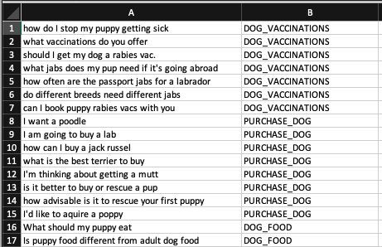

We should ensure that the file is labelled **‘<your topic>_Blindset.csv’** and placed in the **data** subfolder:

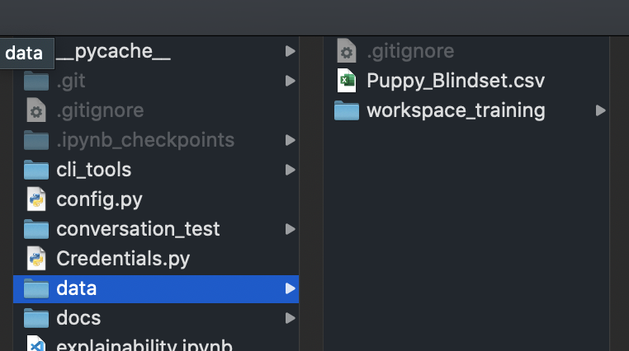

#### Setup

**blindset.py** currently sits in the **conversation_test** sub-folder. We need to move it up one level so it sits in the parent directory:

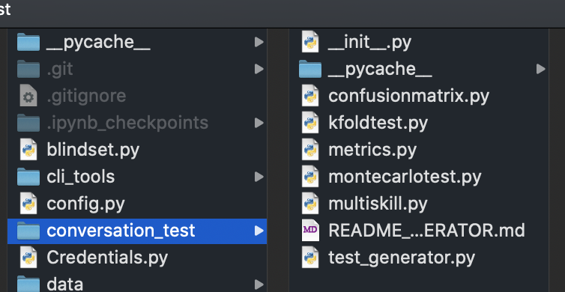



*Todo:* It may make sense to amend the import references in the blindset file so it runs from within **conversation_test** sub-folder

#### Run Command

Within your command prompt or terminal, ensure you’re in the parent toolset directory. You can do this with:

*cd <the file path to your codebase>*

e.g. *cd /Users/chungleu@uk.ibm.com/Documents/Projects/intent_training_tools*

Once you’re in the correct directory, we will run the python script. We will call the blindset.py with a topic argument (your Skill in lowercase) we want to run, in this case ‘puppy’.

*python blindset.py <your topic name>*

e.g.

*python blindset.py puppy*

This will run the blindset tool against your live Watson Assistant. It will be much quicker than the K-Fold test as it doesn’t need to create and destroy new skills when it runs.

#### Results

You will be able to see your results in the **results** sub-folder. The blindset test will create two timestamped files:

* Raw results
* Metric results

The raw results will show:

* An index
* The original utterance
* The intent the testers had expected the utterance to match
* R@1 - A binary score that indicates whether the expected intent matched the Assistant’s highest confidence output intent *and* the confidence for the output intent exceeded the threshold
* TP - A binary score that indicates whether the expected intent matched the Assistant’s highest confidence output intent
* 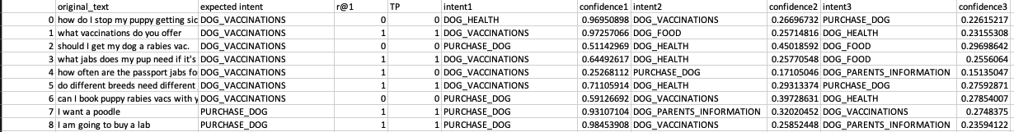The top 3 output intents and their confidences for the given utterances

The metrics results show:

* The Workspaces’ intents
* Threshold
* Number of utterances per intent in the training data
* Performance metrics (Accuracy, Precision, Recall, F1 Score)
* Confusion Matrix counts (False-negatives, False-positives, True-positives, True-negatives)
* 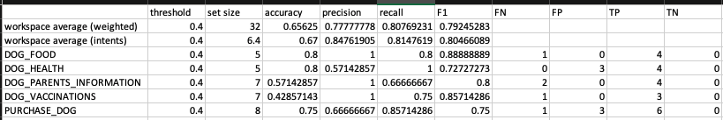Workspace averages. The weighted score accounts for different numbers of utterances per intent in the blindset data

### Command Line Tools - K-Fold Testing

You may not want to run the K-Fold test from within the **exploratory_analysis** notebook. Users can run the K-Fold test directly in the command line. This also gives us the ability to see the raw K-Fold outputs (per utterance) as well as the overall performance metrics.

#### Data Preparation

Make sure your data is loaded correctly according to the instructions in the ‘Load Local Data’ section on page 4.

#### Credentials and Threshold setting

The K-Fold test run from the command line uses the credentials stored in **Credentials.py**. Ensure that your credentials are set for the skills you want to test:



You will also need to ensure that your confidence threshold is correctly set. This is also found in the **Credentials.py** file. At the bottom, you will see that the default threshold is set to 0.4 (for topics that aren’t “master” or “exception-handling”.

Change the below to match the confidence threshold in your architecture:

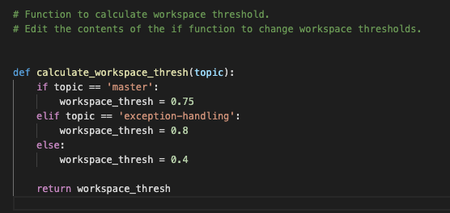

#### Navigate to Conversation Tests

In your command prompt or terminal, navigate to the **conversation_test** subfolder where the **kfoldtest.py** file sits:

*cd <the file path to your conversation_test folder in codebase>*

e.g. *cd /Users/chungleu@uk.ibm.com/Documents/Projects/intent_training_tools/conversation_test*

#### Run the K-Fold

You can inspect the K-Fold test options in the command line by running:

*python kfoldtest.py --help*

We see that we can set parameters for running the K-Fold test:

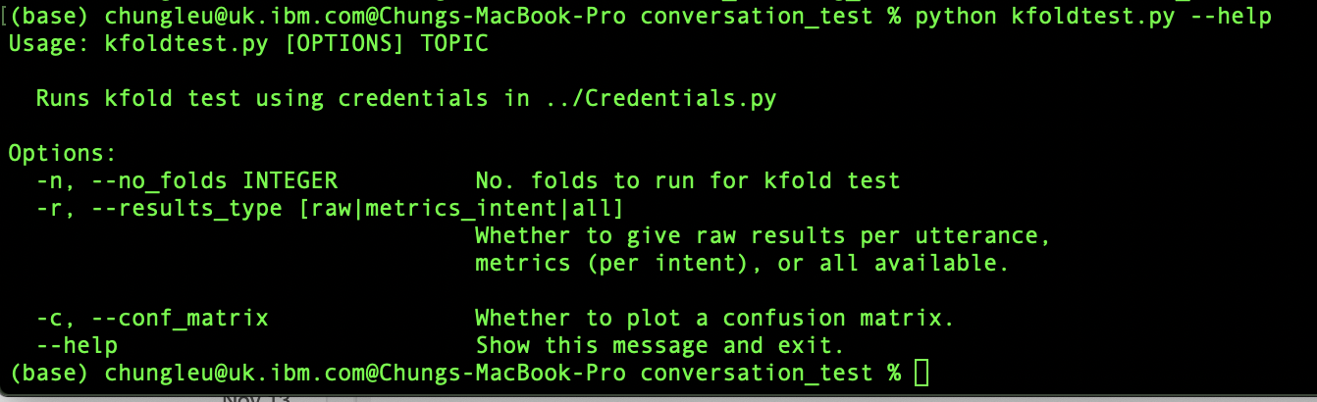

We can set:

* **-n** the number of folds we want
* **-r** the results type (raw, metrics_intent, or all)
* **-c** whether to plot a confusion matrix or not (optional)

If you want a confusion matrix, include the **-c** tag, otherwise, ignore it

In this example, we will run it for 5 folds, all results (metrics and raw), and ignore the confusion matrix:

*python kfoldtest.py puppy -n 5 -r all*

